

American International University-Bangladesh (AIUB)  
**Department of Computer Science and Engineering   
Faculty of Science &Technology (FST)  
Fall 20-21  
CSC 00191- Object Oriented Analysis and Design (OOAD)**

**Section: L**

**Project Title: Airline Reservation System**

**Submitted by:**

|  |  |
| --- | --- |
| **Name** | **ID** |
| 1. **Argho Prasad Singha** | **20-42906-1** |
| 1. **Partha Malakar** | **20-42908-1** |
| 1. **Saiful Islam** | **20-42585-1** |
| 1. **Anonnya Sarkar** | **20-42600-1** |

**Submitted to:**

**MD. ANWARUL KABIR**

**Sr. Assistant Professor**

**Department of Computer Science**

# Airline Reservation System

**Project Scenario:**

In an airline reservation system, A customer will search for flight in airport server. The customer can check the availability. The customer will select the details of the flight. First, he/she have to select destination. Then he/she have to select the preferable date and time. After selecting, the server will check if there is any flight available of that particular time. If yes then server will ask for further details and if not, the server will deny. For the available flight, customer will check no. of seat and category of seat which are available. There are two category of seats which are economy and business class. Then server asks if the customer is interested to go further for reservation. To confirm the flight, the customer will login to the server as a passenger. After verifying the information of the customer by server, the server will show the amount to pay. If the customer wants to confirm the reservation, he/she have to pay the bill. To pay the amount the customer will enter the credit card info and verify it. If the information is not verified it will ask again to enter correct details. After verifying the customer will pay the bill and confirm the reservation.

**Justifications:**

* This system saves our time and help people to do other important work.
* A man become relaxed less after reserving a seat.
* People may reserve seats after observing the rest amount the seats unreserved.
* People will be able to reserve his own seat according to his choice by using internet service.

**Use Case Diagram**

**Case study for Use Case diagram:**

In an airline reservation system, A customer will search for flight in airport server. The customer can check the availability. The customer will select the details of the flight. First, he/she have to select destination. Then he/she have to select the preferable date and time. After selecting, the server will check if there is any flight available of that particular time. If yes then server will ask for further details and if not, the server will deny. For the available flight, customer will check no. of seat and category of seat which are available. There are two category of seats which are economy and business class. Then server asks if the customer is interested to go further for reservation. To confirm the flight, the customer will login to the server as a passenger. After verifying the information of the customer by server, the server will show the amount to pay. If the customer wants to confirm the reservation, he/she have to pay the bill. To pay the amount the customer will enter the credit card info and verify it. If the information is not verified it will ask again to enter correct details. After verifying the customer will pay the bill and confirm the reservation.

**Users:**

**Actor Corresponding use case**

search flight

**customer** check availability flight

select flight details

select destination

select date and time

check no. of seat and category of seat (check availability)

**server** Seat available (economy and business class)

check flight availability

Display Available Flight

Flight unavailable

further for reservation

show the amount to pay

confirm the reservation

Verify information

Verify cc info

**passenger**  login the server

pay the bill

confirm the reservation

**Use Case Diagram:**

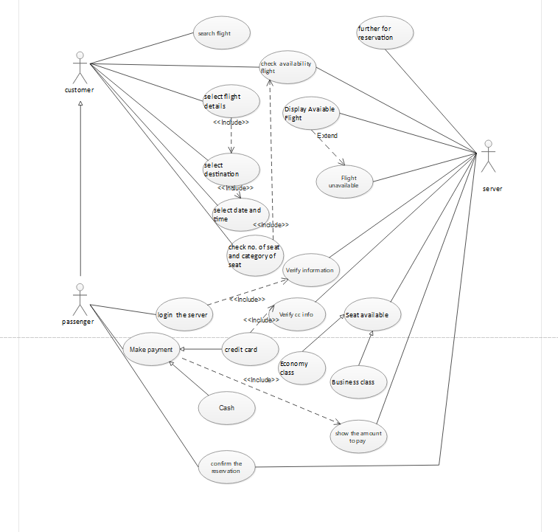

**Class Diagram**

**Case study for class diagram:**

In an airline reservation system, A customer will see any number of flights in airport server. The customer may select exactly one destination of flight from server. Each destination has any number of customers. The server may check zero or more flight available of that particular Destination. Every flight has to be in airport server. The customer can reserve zero or one seat from any category of seat through the server. Each seat has exactly one customer. There are two category of seats which are economy and business class belongs to every flight. Each category has any number of passengers. One passenger may belong to exactly one flight at a time. Not all customers are passengers.

**Class Diagram:**

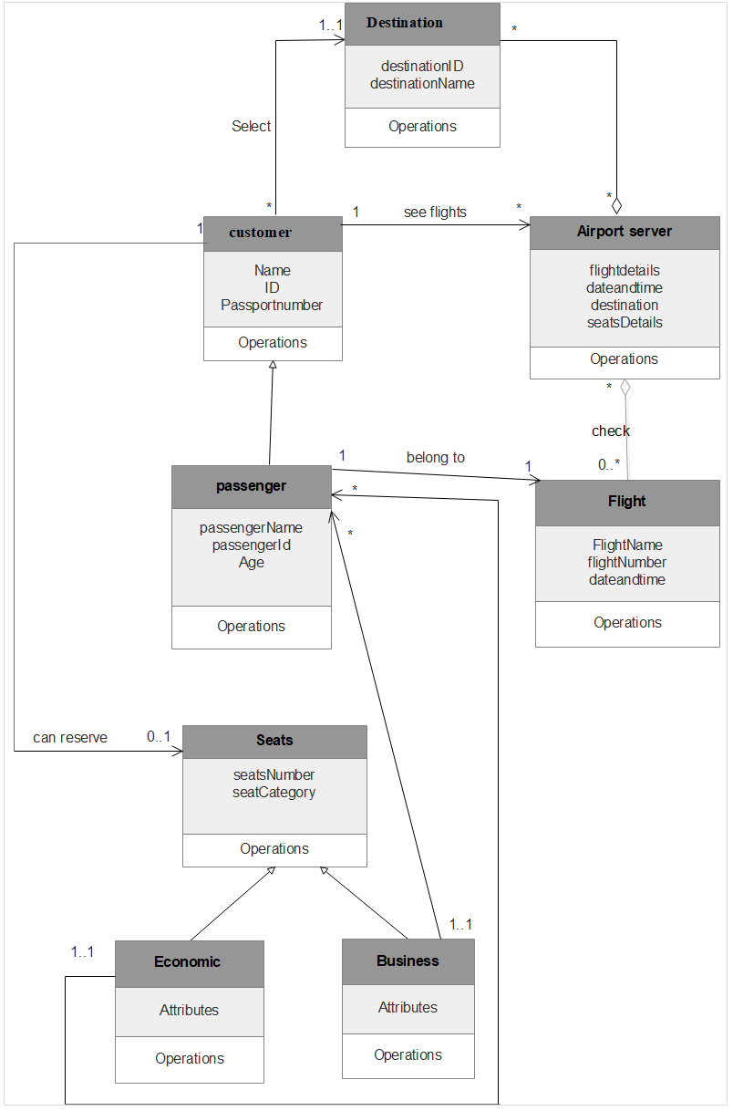

**Activity Diagram**

**Case Studies for activity diagram:**

In an online airlines reservation system, a customer places a request to the system selecting the departure and arrival destinations and also the date of departure. The system then gets all the carrier names and their time schedule from the flight database. Once the carrier names and their time schedules are received the system displays the options of the carriers and the schedule to the customer. If the customer likes any one of the options, he selects the option. But if the customer doesn’t like any option he can go back and select a new date of departure or he can close the application. After selecting an option, the system asks for customer details and credit card information. The system verifies the credit card. If the credit card is valid, the system writes all the booking information in the booking database and sends customer information to the carrier simultaneously. If the verification of the credit card fails, the system sends an error message to the customer and requests for credit card information again. The verification process is done again. If the credit card verification fails for three times the system cancels the booking process and sends a warning message to the credit card agent at the same time. Once the booking is done the system passes the message to the interface and the interface generates a bill and sends it to the customer.

**Activity Diagram:**

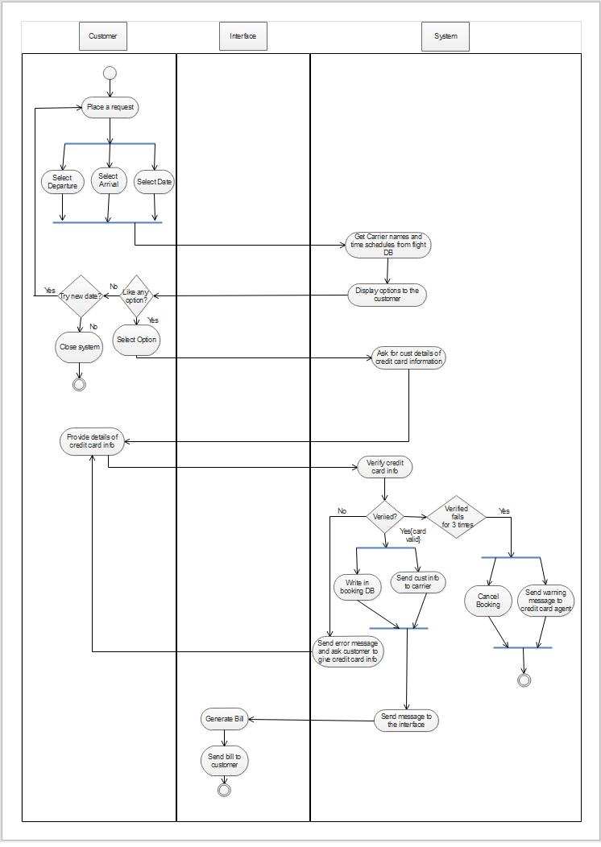

**Sequence Diagram**

**Case study for sequence diagram:**

In an airline reservation system, A customer will search for flight in airport server. To know the availability, the customer has to select the details of the flight so that the customer can be sure about confirming. First, the customer will select details like destination, date & time. After selecting, the server will see if there is any flight available of that particular time. If yes then server will ask for further details and if not, the server will deny. For the available flight, customer will select the flight. Now the server will ask the customer to select seats from that flight. But customer needs to login to select seats. Then the server will show the customer the summary of that flight. Then comes the booking process. If the customer wants to confirm the reservation, he/she have to pay the bill otherwise the ticket will be cancelled. To pay the amount the customer will enter the credit card info and verify it. After verifying the customer will pay the bill and confirm the reservation. If payment gets verified, the server will return a passenger copy and show the tickets to the customer. If not, then the server will decline the reservation.

**Sequence Diagram:**

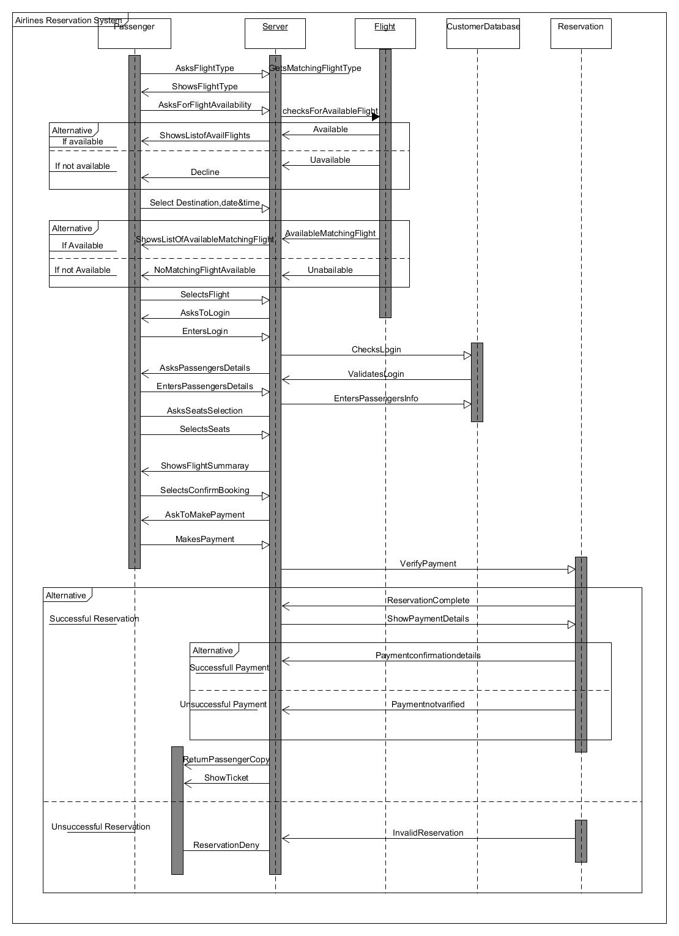

**Statechart Diagram**

**Case study for statechart diagram:**

In an airline reservation system, Airport server object is created. A customer will search for flight in airport server. Among various choices, in order to find his desired flight, the customer has to select the details of the flight. The server shows details of the flight like destination, seat numbers, time of flight, amount to be paid etc. If there is no seat available, the process ends showing a message “No available seat”. Now the server asks if he want to confirm the reservation or not. If the customer wants to complete reservation, he will be promoted to log in. Otherwise, the ticket will be cancelled.

To confirm reservation, server asks the customer to login. Customer enters login info. The customer fills in required info like email, password and solves captcha. If the captcha is not right it asks to solve another captcha. Login if valid will give access to account. If invalid login will be requested again. After gaining access to account reservation or cancellation of flight tickets can be done. After processing of credit card, transaction is done and ticket is printed.

**Statechart Diagarm:**

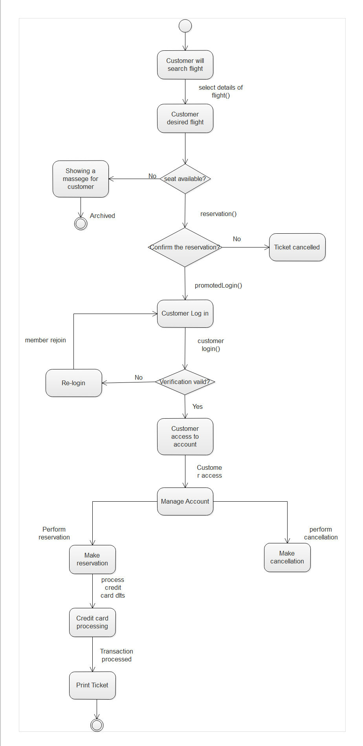

**Conclusion:**

By using this software customer can easily know about flight details and book one’s ticket without going to the airport. In this covid situation we are trying to avoid crowd and do everything by using our smart devices and smart network. We can reduce crowd from airport though this software. As this software is easy to use, one can easily know information by it.